Overview
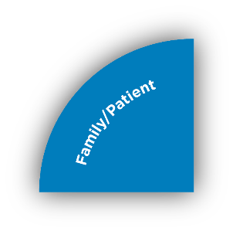
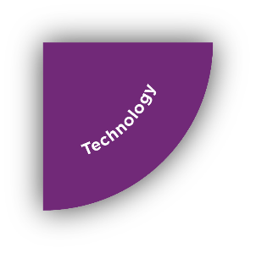
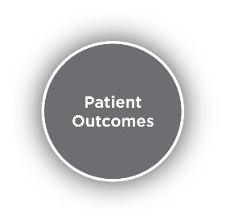
The digital maturity level of healthcare organizations has significantly increased over the last 10 years. Clinical practice across venues of care is forever more reliant on enabling-IT solutions and applications. As a result, clinical workflows have evolved and therefore have brought new IT challenges for healthcare organizations to deal with. With today’s heterogeneous or best of breed environments within healthcare IT, it is often difficult for healthcare organization to ensure standardization of the methods that end users use to access various software platforms. This process is further complicated by the increased adoption of mobile solutions used by clinicians in their day to day operations. Mobility in the IT space introduces further challenges around the reliability and security of wireless network access. In addition, organizations strive to apply international best practice recommendations around the design, build, and management of the core IT and networking infrastructure while trying to optimize the total cost of ownership. While there are typically many vendors that specialize in specific individual building blocks of the service delivery infrastructure (i.e. IT infrastructure, wired or wireless networks, security), clients are faced with the task of achieving delicate balance between cost, scope and flexibility, and quality while continuing to focus on the ultimate goal for any healthcare organization: positive patient outcomes.

Cerner has dedicated the last 38 years to healthcare Informatics to develop multiple platforms, e.g. EMR, Device Integration, Population Health & Research to support complex clinical workflows and patient outcomes. Our omnipresence across the healthcare continuum has enabled us to shore up a wealth of intellectual capital to ensure that clinical practice always remains at the forefront to drive all our value propositions. Cerner aims at helping clients achieve the balance between the various requirements of IT solutions delivery while focusing on positive patient outcomes by following a holistic approach to IT service delivery.

The Cerner Delivery Assurance solution package is a comprehensive methodology to ensure reliable, efficient, user friendly, and secure end user access to IT systems within the healthcare organization

Solution Components

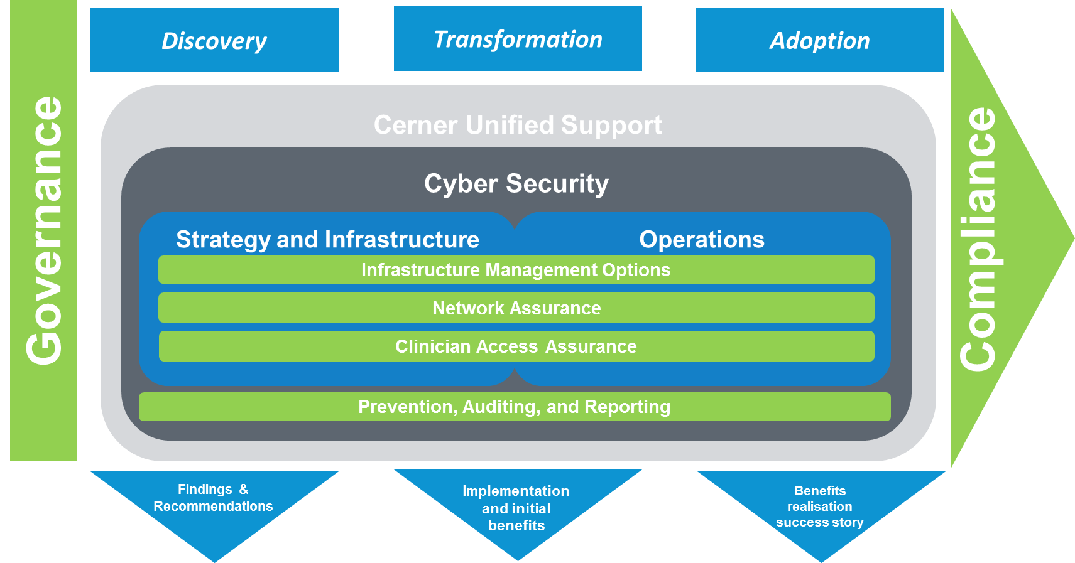

Process

Cerner recommends a 3-staged approach of Discovery, Transformation and Adoption as illustrated above. Our aim is to ensure that through such a holistic and collaborative engagement, our clients can achieve the highest value/benefits possible – supporting the required business processes and therefore fulfilling the client’s vision, as well as meeting the immediate business needs and challenges.
The Discovery stage helps to develop and create a prioritized road map for the most appropriate project investments and organizational change initiatives, collecting information to create benchmarks against international standards as well as the operations of other organizations.

During the Transformation stage, Cerner and the client team will implement all the recommendations derived and agreed during the initial Discovery stage with Senior Responsible Owner of the client organization. The scope of such an implementation will inevitably vary due to the specifics of the findings and the business priorities to be addressed at each organization.
The Adoption & Management stage will be focused on the consolidation of the improvements achieved during the Transformation stage. It is vital to complete and finalise the benefits realisation portion of this project. The goals of the Adoption Stage are to ensure that the changes implemented during the Transformation Stage are being observed and proliferated into the relevant departments or service area of the organization to analyze the outcomes against the projected outcomes for further adjustments.

Approach

Cerner’s delivery assurance package is based on a layered approach to Integrated Service Management(ISM) and is based on the Service Assurance(SA) principles eTOM and ITIL from the telecommunications industry. As a large consumer facing provider, telecommunication providers often focus on the person centric quality of service delivery and not just the practical or technical aspects of accessing an IT service(e.g. accessing data over the internet, or making a phone call). This approach when applied to healthcare can be very beneficial for an organization’s clinical operations as it segregates the clinical workflows from the unnecessary complexities often associated with IT tools. The aim is to provide IT services(i.e. useful data) to the organization’s healthcare provider in the most flexible, reliable, and secure way without overburdening the organization with costs associated with the “best of breed” approach of contracting with individual specialized vendors that have no interest or capability to understand the clinical and technical challenges of the client’s organization.

Cerner’s layered approach as illustrated above, starts with the unified support structure: a single organization that can have an end to end view and accountability over the implementation, support, and operations of the whole IT service delivery platform in the healthcare organization. This platform starts with the EMR, but spans other enterprise applications, and is highly dependent on the IT and networking infrastructure used to delivery these applications.

The second layer is security. Security is an aspect that needs to be handled holistically on layers of the technology stack and IT hosting stack.

The core layer is focused around design, build, and operations of the backend IT infrastructure (i.e. EMR and enterprise application infrastructure), the front end IT environment (mobile and desktop), and the underlying networks (WLAN, LAN, WAN, MAN) that deliver these solutions to the end user.

